Touch Move
Everyone knows the touch move rule don’t they. If you touch a piece then you must move it. Simple!
However, this move can be a bit more complicated than some players realise. The following position arose in a Northumberland League match.
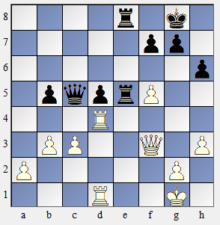
White played Rxd5. This move leaves his own king in check. The opponent was originally taken by surprise by what was an unexpected move. It can take a bit of time for a player to realise why the move was unexpected. Indeed, players have resigned as a result of the surprise effect caused by such an illegal move.
In this case the opponent did point out the illegal move. The clock was reset giving Black an additional 2 minutes.
At this point Black, an experienced arbiter, announced that the touch move rule applied and restarted White’s clock.
White correctly pointed out that the rook could not move and therefore considered himself free to make any legal move. When Black pointed out that the pawn too had been touched White did not deny it (indeed that move was written on the scoresheet) but didn’t accept that it had been deliberately touched with the intention of moving it. Unfortunately, no copy of the Laws was available (all clubs should have one stored with their equipment) and so the two captains had to be involved. The White captain agreed that Qxe5 had to be played. White resigned as the queen is lost.
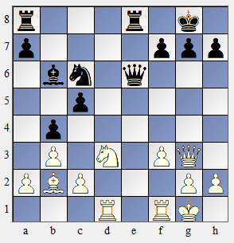
The second diagram shows another similar situation where it is easy to forget the touch move rule. Here Black plays 1 … c4 and White plays 2 Qxg7 thinking it is mate.
Black quickly points out that White is the victim of a discovered check so cannot make that move. White then plays 2 Nf2 (or 2 Rh1) blocking the check.
However this contravenes the touch move rule. An arbiter would insist on 2 Qf2 being played.
Black however claimed that 2 Nf2 was a second illegal move and wanted to be awarded the game. Although the knight move is not allowed it is not considered as an illegal move. The claim of the game is dismissed.
Situation 3. A player castles by lifting the rook with his right hand and moving it to f1. He then picks up his king with his left hand and moves it to g1. The opponent immediately claims that White has played an illegal move as he has used both hands. Using two hands to make a move is indeed illegal but as the player has not pressed his clock he would, under normal circumstances, be allowed to reposition the rook and king on their original squares and then castle using only one hand. But here there is another complication. The player touched the rook first. He is therefore not allowed to castle. Castling is a king move, so the king should be touched first. In this case the move Rf1 must be played.
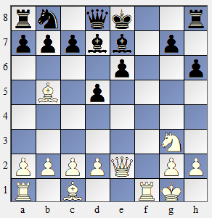
Another castling problem that can arise in novice events is shown in the third diagram. Here Black tries to castle but it is illegal since the king crosses f8 which is under attack. The king cannot move. White claims that since the rook was touched after the king it must still go to f8. The White claim is rejected. As castling is defined as a king move, the rook does not have to move at all. Black is free to make any move that he wants.
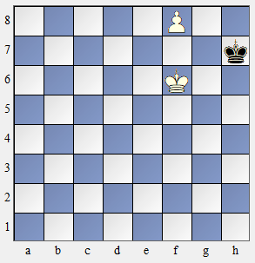
Another situation which can cause trouble with the touch move rule is promotion. The fourth diagram shows a very simple position.
Here White is about to promote. Promoting to a queen will mean stalemate. In how many of the following situations must White promote to a queen?
- White lifts a queen from the side of the board but changes it to a rook before putting it on the square;
- White lifts the queen and places it on the board but before releasing it changes it to a rook;
- White announces queen but instead promotes to a rook;
- White announces rook and presses the clock.
The answer is two! But which two? The answer here is (b) and (d). The queen is only considered to be touched after it has made contact with the promotion square. [In this case that must be f8 but if the pawn was still on f7 the queen touching any of e8, f8 or g8 would make it active.] Therefore (a) does not require a queen promotion. Nor does (c). Announcing “queen” may be a distraction but it does not comit the player to promoting to that piece. In (d) White has played an illegal move by pressing the clock before promoting to a piece. In these circumstances the promoted piece must be a queen. That would still be the case even if White had immediately put the rook on the board after pressing the clock. As in (c) the announcement of the piece counts for nothing.

