Illegal Moves
The Laws of chess now specifies several ‘actions’ that are to be considered as illegal moves. A combination of any two of these normally results in the loss of the game to the player committing them. I say normally because there are situations where a second illegal move means that the game will end in a draw. These are discussed later. The first illegal move has a two minute penalty (one minute in blitz). The two minutes is awarded to the opponent.
It is important to note that for a move to count the player must press the clock. An opponent who claims before the clock is pressed has actually, very kindly, stopped the offence from having been committed and the player can correct his error without penalty.
What offences are classified as illegal moves?
The first is the normal definition where a piece is moved to a square which is not allowed by the definition of its move. Common examples of this would be:
- a knight moving two squares diagonally;
- a bishop moving to a square of a different colour;
- a rook or queen jumping over another piece on its way to its destination square;
- moving a piece which exposes its king to check;
- making a move which leaves its king in check;
- castling out of check;
- castling through check;
- castling with a king or rook that has already moved.
A second type of illegal move is to use two hands to make a move. Examples of this would be:
- capturing using two hands
- castling using two hands
- promoting using two hands
Note that moving with one hand and pressing the clock with the other is an illegal action but does not count as an illegal move.
A third type also concerns promotion. In this case the promotion is not completed. The pawn is moved to the far side of the board and the clock is pressed before the pawn is replaced. This counts not only as an illegal move but also the pawn must be replaced by a queen. The player is not allowed to promote to another pieces.
The fourth action which counts as an illegal move is to press the clock without having made a move.
Provided he has not pressed his clock, a player can negate the using two hands offence by restoring the position to what it was before making the move and then repeating the repositioning using only one hand.
Even if the clock is pressed only one hand is considered to have been used in the following situations:
- in capturing, the player removes the captured piece with the same hand as he moved his own piece but puts it in his other hand to place it at the side of the board;
- in promotion, the player lifts a queen (or whatever) with one hand but transfers it to the hand moving the pawn without the queen having touched the promotion square before the transfer of hands took place.
Pressing the clock without moving can cause some problems in a few cases.
Possibly the most common of these is where the opponent makes an illegal move and the player restarts his clock. This is not a problem in Standard or Rapid games but in Blitz it can be argued that by doing this the player has accepted the opponent’s illegal move by making an illegal move of his own. The opponent can then either reply to the non-move or claim that an illegal move has been made.
In Standard games a player may return to the board and see his clock running and, missing the opponent’s reply, assume that he forgot to press his clock. In situations like this where the clock has been pressed ‘accidently’ the player will be deemed to have made an illegal move unless he can convince the arbiter otherwise.
When does a second illegal move not lose?
A second illegal move does not always lose. The game will be declared drawn in the following circumstances:
- if checkmate is impossible for the opponent to achieve e.g he only has a lone king;
- in the case of using two hands, when the move leads directly (or by a series of forced moves) to checkmate or stalemate;
- In the case of failing to exchange the pawn for another piece on promotion the same conditions as in (b) apply.
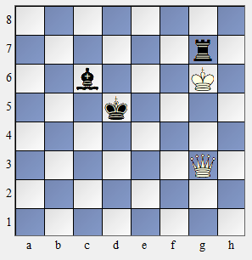
The following are examples of drawn games following a second illegal move:
1a. Here White plays Kxg7 but uses both hands. It is impossible to get mate with king and bishop. If the queen is replaced by a rook, or even simply removed the game is drawn too. But if instead of a queen White had a bishop, knight or pawn on g3 the game would be a win for Black. Indeed, the knight or pawn anywhere and a black squared bishop would give Black the win but a white squared bishop would be a draw.

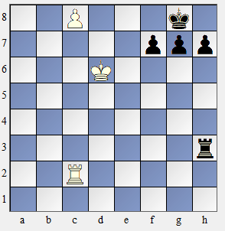
2bc. In this position White uses two hands to promote to a queen or simply presses his clock without completing the promotion. In both cases the White move is illegal but in both cases the pawn must be promoted to a queen which would give checkmate so the outcome is a draw. But notice if the Black rook was on e3 instead then it could block the checkmate so the result would be a win for Black as Qxe8 checkmate is not a forced move even if it is the only logical move.

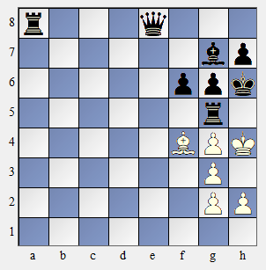

3b. In this position White plays 1 Bxg5 using both hands. This too is a draw as the only legal moves are 1 … fxg5 (forced) 2 Kh3 and no matter what Black plays White has no legal third move.

