FIDE Laws of Chess cover over the board play. The English text is the authentic version of the Laws of Chess which was adopted at the 67th FIDE Congress at Yerevan Sep.-Oct. 1996, coming into force on 1 July 1997. In these Laws, the words ‘he’, ‘him’, and ‘his’ include ‘she’, ‘her’, and ‘hers’.
RULES OF PLAY
Article 1: The nature and objectives of the game of Chess
1.1 | The game of Chess is played between two opponents who move pieces alternately on a square board called a ‘Chessboard’. The player with the white pieces commences the game. A player is said to ‘have the move’, when his opponent’s move has been completed.
1.2 | The objective of each player is to place the opponent’s king ‘under attack’ in such a way that the opponent has no legal move which would avoid the ‘capture’ of the King on the following move. The player who achieves this is said to have ‘checkmated’ the opponent and to have won the game. The opponent who has been checkmated has lost the game.
1.3 | If the position is such that neither player can possibly checkmate, the game is drawn.
Article 2: The initial position of the pieces on the Chessboard
2.1 | The Chessboard is composed of an 8x8 grid of 64 equal squares alternately light (the ‘white’ squares) and dark (the ‘black’ squares).  The Chessboard is placed between the players in such a way that the near corner square to the right of the player is white.
2.2 | At the beginning of the game one player has 16 light colored pieces (the ‘white’ pieces); the other has 16 dark colored pieces (the ‘black’ pieces):  These pieces are as follows:  White:  A white King, usually indicated by the symbol ............  A white Queen, usually indicated by the symbol ........  Two white Rooks, usually indicated by the symbol ....  Two white Bishops, usually indicated by the symbol .  Two white Knights, usually indicated by the symbol ..  Eight white Pawns, usually indicated by the symbol ..  Black:  A black King, usually indicated by the symbol ............  A black Queen, usually indicated by the symbol ........  Two black Rooks, usually indicated by the symbol ....  Two black Bishops, usually indicated by the symbol .  Two black Knights, usually indicated by the symbol ..  Eight black Pawns, usually indicated by the symbol ..
2.3 | The initial position of the pieces on the Chessboard is as follows:  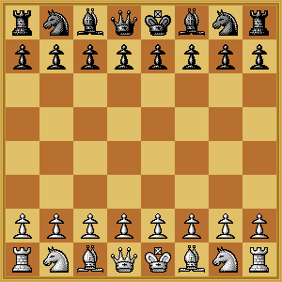
2.4 | The eight vertical columns of squares are called ‘files’. The eight horizontal rows of squares are called ‘ranks’. A straight line of squares of the same color, touching corner to corner, is called a ‘diagonal’.
Article 3: The moves of the pieces
3.1 | No piece can be moved to a square occupied by a piece of the same color. If a piece moves to a square occupied by an opponent‘s piece the latter is captured and removed from the Chessboard as part of the same move. A piece is said to attack a square if the piece could make a capture on that square according to Articles 3.2 to 3.5.
3.2 | a. The Queen moves to any square along the file, the rank or a diagonal  on which it stands:  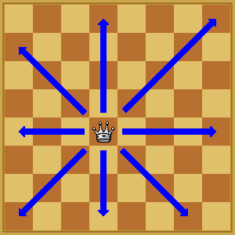  b. The Rook moves to any square along the file or the rank on which it  stands:  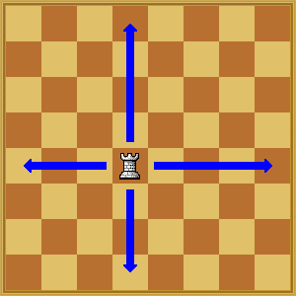  c. The Bishop moves to any square of its own color along a diagonal on  which it stands:  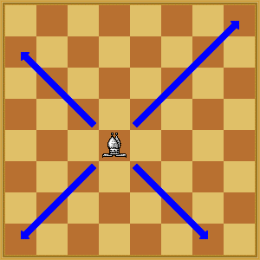  When making these moves the Queen, Rook or Bishop cannot move over any intervening pieces.
3.3 | The Knight moves to one of the squares nearest to that on which it stands but not on the same rank, file or diagonal. It does not pass directly over any intervening square.  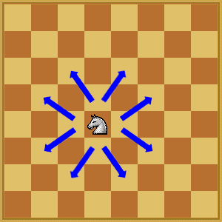
3.4 | a. The Pawn moves forward to the unoccupied square immediately in  front of it on the same file, or  b. on its first move the Pawn may advance two squares along the same  file provided both squares are unoccupied, or  c. the Pawn moves to a square occupied by an opponent’s piece which  is diagonally in front of it on an adjacent file (“x”), capturing that piece.  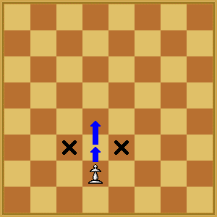  d. A Pawn attacking a square crossed by an opponent’s Pawn which has  advanced two squares in one move from its original square may  capture this opponent’s Pawn as though the latter had been moved  only one square. This capture can be made only on the move following  this advance and is called an ‘en passant’ capture.  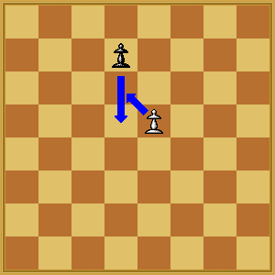  e. When a Pawn reaches the rank furthest from its starting position it  must be exchanged as part of the same move for a Queen, Rook,  Bishop or Knight of the same color. The player’s choice is not  restricted to pieces that have been captured previously. This  exchange of a Pawn for another piece is called ‘promotion’ and the  effect of the new piece is immediate.
3.5 | (a) The King can move in two different ways, by:  a. moving to any adjoining square that is not attacked by one or more of  the opponent’s pieces,  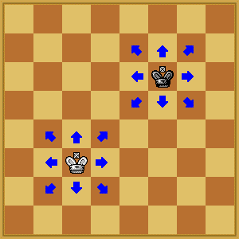  or  b. ‘castling’. This is a move of the King and either rook of the same color  on the same rank, counting as a single move of the King and executed  as follows: the King is transferred from its original square two squares  towards the Rook, then that Rook is transferred over the King to the  square the King has just crossed.  Before black kingside castling After black kingside castling  Before white kingside castling After white kingside castling  Before black queenside castling After black queenside castling  Before white queenside castling After white queenside castling  (1) Castling is illegal:  a. if the King has already been moved, or  b. with a Rook that has already been moved  (2) Castling is prevented for the time being:  a. if the square on which the King stands, or t he square which it must  cross, or the square which it is to occupy, is attacked by one or more  of the opponent’s pieces.  b. if there is any piece between the King and the Rook with which  castling is to be effected.  (b) The King is said to be ‘in check’, if it is under attack by one or more of the opponent’s pieces, even if such pieces cannot themselves move.  Declaring a check is not obligatory.  A player must not make a move which places or leaves his own King in check.
4.1 | Article 4: The act of moving the pieces  Each move must be made with one hand only.
4.2 | Provided that he first expresses his intention (e.g. by saying “j’adoube”), the player having the move may adjust one or more pieces on their squares.
4.3 | Except as provided in Article 4.2, if the player having the move deliberately touches on the Chessboard:  a. one or more pieces of the same color, he must move or capture the  first piece touched that can be moved or captured, or  b. one piece of each color, he must capture the opponent’s piece with his  piece or, if this is illegal, move or capture the first piece touched which  can be moved or captured. If it is unclear the player’s own piece shall  be considered to have been touched before his opponent’s.
4.4 | a. If a player deliberately touches his King and Rook he must castle on  that side if it is legal.  b. If a player deliberately t ouches a Rook and then his King he is not  allowed to castle on that side on that move and the situation shall be  governed by Article 4.3.  c. If a player, intending to castle touches the King or King and Rook at  the same time, but castling on that side is illegal, the player must  choose either to castle on the other side, provided that castling on that  side is legal, or to move his king. If the King has no legal move, the  player is free to make any legal move.
4.5 | If none of the pieces touched can be moved or captured, the player may make any legal move.
4.6 | If the opponent violates Article 4.3 or 4.4, the player cannot claim this after he himself deliberately touches a piece.
4.7 | When, as a legal move or part of a legal move, a piece has been released on a square, it cannot then be moved to another square. The move is considered to be made when all the relevant requirements of Article 3 have been fulfilled.
Article 5: The completed game
5.1 | a. The game is won by the player who has checkmated his opponent’s  King with a legal move. This immediately ends the game.  b. The game is won by the player whose opponent declares he resigns.  This immediately ends the game.
5.2 | The game is drawn when the player to move has no legal move and his King is not in check. The game is said to end in ‘stalemate’. This immediately ends the game.
5.3 | The game is drawn upon agreement between the two players during the game. This immediately ends the game. (See Article 9.1)
5.4 | The game may be drawn if the identical position is about to appear or has appeared on the Chessboard three times. (See Article 9.2)
5.5 | The game may be drawn if the last 50 consecutive moves have been made by each player without the movement of any Pawn and without the capture of any piece. (See Article 9.3)
TOURNAMENT RULES
Article 6: The Chess clock
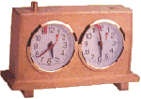
6.1 | ‘Chess clock’ means a clock with two time displays, connected to each other in such a way that only one of them can run at one time.  ‘Clock’ in the Laws of Chess means one of the two time displays.  ‘Flag fall’ means the expiry of the allotted time for a player.
6.2 | When using a Chess clock, each player must make a certain number or all moves in an allotted period of time and/or may be allocated an additional amount of time after each move. All this must be specified in advance. The time saved by a player during one period is added to his time available for the next period, except in the ‘time delay’ mode.  In the time delay mode both players receive an allotted ‘main thinking time’. They also receive a ‘fixed extra time’ for every move. The count down of the main time only commences after the fixed time has expired. Provided the player stops his clock before the expiry of the fixed time, the main thinking time does not change, irrespective of the proportion of the fixed time used.
6.3 | Each time display has a ‘flag’. Immediately after a flag falls, the requirements of Article 6.2 must be checked.
6.4 | The arbiter decides where the Chess clock is placed.
6.5 | At the time determined for the start of the game the clock of the player who has the white pieces is started.
6.6 | The player shall lose the game if he arrives at the Chessboard more than one hour after the scheduled start of the session (unless the rules of the competition specify or the arbiter decides otherwise).
6.7 | a. During the game each player, having made his move on the Chess  board, shall stop his own clock and start his opponent’s clock. A  player must always be allowed to stop his clock. His move is not  considered to have been completed until he has done so, unless the  made move ends the game (See Articles 5.1, 5.2 and 5.3). The time  between making the move on the Chessboard and stopping his own  clock and starting his opponent‘s clock is regarded as part of the time  allotted to the player.  b. A player must stop his clock with the same hand as that with which he  made his move. It is forbidden to keep the finger on the button or to  ‘hover’ over it.  c. The players must handle the Chess clock properly. It is forbidden to  punch it forcibly, to pick it up or to knock it over. Improper clock  handling shall be penalized in accordance with Article 13.4.
6.8 | A flag is considered to have fallen when the arbiter observes the fact or when a valid claim to that effect has been made by either player.
6.9 | Except where Articles 5.1, 5.2 and 5.3 apply, if a player does not complete the prescribed number of moves in the allotted time, the game is lost by the player. However, the game is drawn, if the position is such that the opponent cannot checkmate the player by any possible series of legal moves, even with the most unskilled counterplay).
6.10 | Every indication given by the clocks is considered to be conclusive in the absence of any evident defect. A Chess clock with an evident defect shall be replaced. The arbiter shall use his best judgment when determining the times to be shown on the replacement Chess clock.
6.11 | If both flags have fallen and it is impossible to establish which flag fell first, the game shall continue.
6.12 | a. If the game needs to be interrupted, the arbiter shall stop the clocks.  b. A player may stop the clocks in order to seek the arbiter’s assistance.  c. The arbiter shall decide when the game is to be restarted.
6.13 | If an irregularity occurs and/or the pieces have to be restored to a previous position, the arbiter shall use his best judgment to determine the times to be shown on the clocks.
6.14 | Screens, monitors, or demonstration boards showing the current position on the Chessboard, the moves and the number of moves made, and clocks which also show the number of moves, are allowed in the playing hall. However, the player may not make a claim based on anything shown in this manner.
Article 7: Illegal positions
7.1 | a. If during a game it is found that the initial position of the pieces was  incorrect, the game shall be cancelled and a new game played.  b. If during a game it is found that the only error is that the Chessboard  has been placed contrary to Article 2 .1, the game continues but the  position reached must be transferred to a correctly placed Chess  board.
7.2 | If a game has begun with colors reversed then it shall continue, unless the arbiter rules otherwise.
7.3 | If a player displaces one or more pieces, he shall re-establish the correct position on his own time. If necessary the opponent has the right to restart the player’s clock without making a move in order to make sure the player re-establishes the correct position on his own time.
7.4 | If during a game it is found that an illegal move has been made, or that pieces have been displaced from their squares, the position before the irregularity shall be re-instated. If the position immediately before the irregularity cannot be identified the game shall continue from the last identifiable position prior to the irregularity. The clocks shall be adjusted according to Article 6.13 and, in the case of an illegal move, Article 4.3 applies to the move replacing the illegal move. The game shall then continue.
Article 8: The recording of the moves
8.1 | In the course of play each player is required to record his own moves and those of his opponent, move after move, as clearly and legibly as possible, in the algebraic notation (Appendix E), on the score sheet prescribed for the competition.  A player may reply to his opponent‘s move before recording it, if he so wishes. He must record his previous move before making another. The offer of a draw must be recorded on the score sheet by both players. (Appendix E.12)  If a player due to physical or religious reasons, is unable to keep score, an amount of time, decided by the arbiter, shall be deducted from his allotted time at the beginning of the game.
8.2 | The score sheet shall be visible to the arbiter at all times.
8.3 | The score sheets are the property of the organizers of the event.
8.4 | If a player has less than five minutes left on his clock and does not have additional time of 30 seconds or more added with each move, then he is not obliged to meet the requirements of Article 8.1. Immediately after one flag has fallen the player must update his score sheet completely.
8.5 | a. If neither player is required to keep score under Article 8.4, the arbiter or  an assistant should try to be present and keep score. In this case,  immediately after one flag has fallen, the arbiter shall stop the clocks.  Then both players shall update their score sheets, using the arbiter‘s or  the opponent‘s score sheet.  b. If only one player is not required to keep score under Article 8.4, he  must update his score sheet completely as soon s a flag has fallen.  Provided it is the player’s move, he may use his opponent’s score sheet.  The player is not permitted to move until after he has completed his own  score sheet and returned his opponent’s.  c. If no complete score sheet is available, the players must reconstruct the  game on a second Chessboard under the control of the arbiter or an  assistant, who shall first record the actual game position before  reconstruction takes place.
8.6 | If the score sheet cannot be brought up to date showing that a player has overstepped the allotted time, the next move made shall be considered as the first of the following time period, unless there is evidence that more moves have been made.
Article 9: The drawn game
9.1 | A player can propose a draw after making a move on the Chessboard. He must do so before stopping his own clock and starting his opponent‘s clock. An offer at any other time during play is still valid, but Article 12.5 must be considered. No conditions can be attached to the offer. In both cases the offer cannot be withdrawn and remains valid until the opponent accepts it, rejects it orally, rejects it by making a move, or the game is concluded in some other way.  The offer of a draw shall be noted by each player on his score sheet with the symbol (=).
9.2 | The game is drawn, upon a correct claim by the player having the move, when the same position, for at least the third time (not necessarily by repetition of moves):  a. is about to appear. If he first writes his move on his score sheet and  declares to the arbiter his intention to make this move, or  b has just appeared.  Positions as in (a) and (b) are considered the same, if the same  player has the move, pieces of the same kind and color occupy the  same squares, and the possible moves o f all the pieces of both  players are the same. Positions are not the same if a Pawn could  have been captured en passant or if the right to castle immediately  or in the future has been changed.
9.3 | The game is drawn, upon a correct claim by the player having the move, if:  a. he writes on his score sheet, and declares to the arbiter his intention  to make a move which shall result in the last 50 moves having been  made by each player without the movement of any pawn and without  the capture of any piece, or  b. the last 50 consecutive moves have been made by each player  without the movement of any Pawn and without the capture of any  piece.
9.4 | If the player makes a move without having claimed the draw he loses the right to claim, as in Article 9.2 or 9.3, on that move.
9.5 | If a player claims a draw as in Article 9.2 or 9.3 he shall immediately stop both clocks. He is not allowed to withdraw his claim:  a. If the claim is found to be correct the game is immediately drawn.  b. If the claim is found to be incorrect, the arbiter shall deduct half of the  claimant‘s remaining time up to a maximum of three minutes and add  three minutes to the opponent‘s remaining time. Then the game shall  continue and the intended move must be made.
9.6 | The game is drawn when a position is reached from which a checkmate cannot occur by any possible series of legal moves, even with the most unskilled play. This immediately ends the game.
Article 10: Quickplay Finish
10.1 | A ‘quickplay finish’ is the last phase of a game, when all the remaining moves must be made in a limited time.
10.2 | If the player has less than two minutes left on his clock, he may claim a draw before his flag falls. He shall stop the clocks and summon the arbiter.  a. If the arbiter is satisfied the opponent is making no effort to win the  game by normal means, or that it is not possible to win by normal  means, then he shall declare the game drawn. Otherwise he shall  postpone his decision.  b. If the arbiter postpones his decision, the opponent may be awarded  two extra minutes thinking time and the game shall continue in the  presence of the arbiter.  c. Having postponed his decision, the arbiter may subsequently declare  the game drawn, even after a flag has fallen.
10.3 | Illegal moves do not necessarily lose. After the action taken under Article 7.4, for a first illegal move by a player the arbiter shall give two minutes extra time to his opponent; for a second illegal move by the same player the arbiter shall give another two minutes extra time to his opponent; for a third illegal move by the same player, the arbiter shall declare the game lost by the player who played incorrectly.
10.4 | If both flags have fallen and it is impossible to establish which flag fell first the game is drawn.
Article 11: Scoring
11.1 | A player who wins his game scores one point (1), a player who loses his game scores no points (0) and a player who draws his game scores a half point (1/2).
Article 12: The conduct of the players
12.1 | High standards of etiquette are expected of the players.
12.2 | During play the players are forbidden to make use of any notes, sources of information, advice, or to analyze on another Chessboard. The score sheet shall be used only for recording the moves, the times of the clocks, the offer of a draw, and matters relating to a claim.
12.3 | No analysis is permitted in the playing area when play is in progress, whether by players or spectators. Players who have finished their games shall be considered to be spectators.
12.4 | The players are not allowed to leave the ‘playing venue’ without permission from the arbiter. The playing venue is defined as the playing area, rest rooms, refreshment area, area set aside for smoking and other places as designated by the arbiter. The player having the move is not allowed to leave the playing area without permission of the arbiter.
12.5 | It is forbidden to distract or annoy the opponent in any manner whatsoever; this includes the persistent offer of a draw.
12.6 | Infraction of any part of the Articles 12.2 to 12.5 shall lead to penalties in accordance with Article 13.4.
12.7 | The game is lost by a player who persistently refuses to comply with the Laws of Chess. The opponent‘s score shall be decided by the arbiter.
12.8 | If both players are found guilty according to Article 12.7, the game shall be declared lost by both players.
Article 13: The role of the arbiter (see Preface)
13.1 | The arbiter shall see that the Laws of Chess are strictly observed.
13.2 | The arbiter shall act in the best interest of the competition. He should ensure that a good playing environment is maintained and that the players are not disturbed. He shall supervise the progress of the competition.
13.3 | The arbiter shall observe the games, especially when the players are short of time, enforce decisions he has made and impose penalties on players where appropriate.
13.4 | Penalties open to the arbiter include:  a. a warning,  b. increasing the remaining time of the opponent,  c. reducing the remaining time of the offending player,  d. declaring the game to be lost,  e. expulsion from the event.
13.5 | The arbiter may award either or both players additional time in the event of external disturbance of the game.
13.6 | The arbiter must not intervene in a game to indicate the number of moves made, except in applying Article 8.5, when at least one player has used all his time. The arbiter shall refrain from informing a player that his opponent has made a move, or that he has failed to press his clock.
13.7 | Spectators and players in other games are not to speak about or otherwise interfere in a game. If necessary, the arbiter may expel offenders from the playing venue.
Article 14: FIDE
14.1 | Member federations may ask FIDE to give an official decision about problems relating to the Laws of Chess.

