Arbiters’ Version

Claiming a Draw
Most players have a reasonable grasp on the Laws of Chess but one area which is a common source of problems is making a draw claim.
The problems come from either the player not understanding what is required or the opponent believing the claim was made incorrectly.
Draws are claimed in three different situations
- Draw by Repetition;
- Draw by the 50 Move Rule; and
- Making a claim in your last two minutes.
Draw by Repetition
If checking a claim of draw by repetition the first thing an arbiter must establish is if the player on the move is making the claim. A player should not claim after he has made a move, even if he has not pressed the clock.
The second thing is that it is the position which must be repeated and not a series of moves. Sometimes repeating moves will lead to a repetition of position but this is not always the case.
The third thing to remember is that the position can occur at any time in the game. The positions do not have to happen in consecutive, or near consecutive, moves.
If a player whose move will cause the position to occur for a third time can claim a draw before moving. Although it is often called a threefold repetition the position only has to be repeated twice. The first time it occurred also counts.
If a player wants to make a claim because the move he is about to play repeats the position then he must not play it but write it on his scoresheet*, stop the clock and get the arbiter. It is polite to let the opponent know why this has been done. If a player simply stops his clock and informs the arbiter that his next move will lead to a draw by repetition the arbiter should inform him of the correct procedure and restart his clock asking him to write down the move and then stop his clock again. If the claim is shown to be wrong then the written move must be played regardless.
(*This is one of only two cases where you are allowed to write the move before playing it.)
If the draw claim is rejected the opponent can still accept a draw. Indeed, provided there minimum number of moves required has been reached, an arbiter might first ask if the opponent accepts the draw offer.

Consider the following position reached after White has just played 1 f4
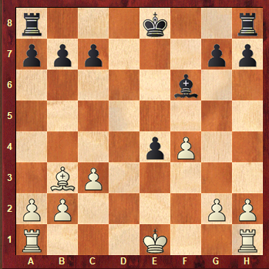
Play continues 1 … Be7 2 Bc4 Bf6 3. Bb3 and the pieces are back on the same squares.
This however is not the same position as 1 exf3 was possible the first time but that move is not possible the second time.
The game continues 3 … Bd8 4 Bc4 Be7 5 Bb3 Bf6 and again the pieces are back on the same squares.
But this is a new position as this time it is White to play whereas it was black in the previous situations.
And still the game continues 6 Rf1 Be7 7 Rh1 Bf6. We now have a 4th position as White can no longer castle king side.
8 Rd1 Be7 9 Ra1 Bf6 and we have a 5th different position as White can no longer castle queen side either. We could have a 6th, 7th and 8th situation where Black loses his castling rights eg 10 Bd1 Rd8 11 Bc2 Ra8 12 Bb3 Rf8 13 Bc2 Rh8 14 Bb3 Bd8 15 Bc2 Be7 16 Bb3 Bf6.
Four additional positions could have been created by having the position with a different player to move after each occurrence of the rook first moving. It is therefore possible to have the pieces on the same squares 14 times before a successful claim of repetition can be made!
Arbiters should step in and declare a game drawn if the same position occurs 5 times.
Draw by the 50 Move Rule
The first thing to note is that in order for a claim to be correct both sides must make 50 moves (not 25 each) without a pawn being moved or a capture made. The implementation of this rule is very similar to repetition. To claim the player must have the move or to write down the move that is to be played. An arbiter should step in and declare the game drawn after 75 moves without a pawn move or capture.
Draw Claim in the Last 2 minutes
If increments are in use then a player cannot claim a draw in the last two minutes (except using the above two methods). No matter how drawish the position looks the player cannot expect the arbiter to award the draw because his opponent is not trying. (But they will!) With increments a player can only claim a draw by repetition or under the 50 move rule.
If draw claims are allowed in the last two minutes decisions can be complicated. A useful ‘rule of thumb’ for the arbiter is that if they have to think about it then the draw claim is rejected.

